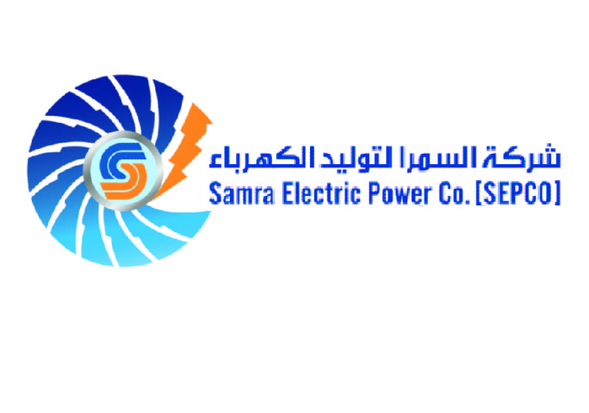

THE HASHMITE KINGDOM OF JORDAN
SAMRA ELECTRIC POWER COMPANY

TENDER NO. 56/ 2026

PART (4)

PUBLIC LIABILITY INSURANCE COVER

SPECIAL CONDITIONS (LIABILITY INSURANCE COVER)

- Cover : Public Liability

- Policy Wording : PCA 94

- Territory : Jordan & worldwide

- Laws & Jurisdiction : Jordan

- Limit of Liability:

Damages : JOD 5 million AOO & in the aggregate.
Injuries : JOD 500,000 AOO & in the aggregate.

- 72 hours S&A pollution.

- 90 days notice of cancellation if requested by the Insurer and 30 days if requested by THE COMPANY

- Cross Liability.

- The company’s advice of accident is considered the company’s right for the claim irrespective of the time to secure the supporting documents of the incident.

- Definitions:

  - “Injuries” means death bodily injury illness or disease of or to any person
  - “Damages” means loss of possession or control of or actual damage of any kind unless subject to the exclusions stated in the policy;

